Binome B3600

BRYANS Isabelle 04027212

SAREMI Zahra

Step 1:

1.Give the XPath expressions to select the following: 1.the official names (country_name/offic_name) of thecountries

//country/country_name/offic_name

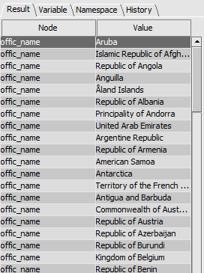

2.the latitude of each country

//country/coordinates/@lat

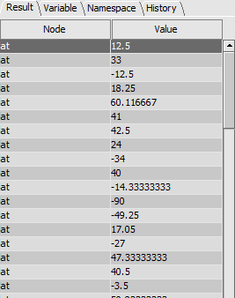

3.the area of each country

//@area

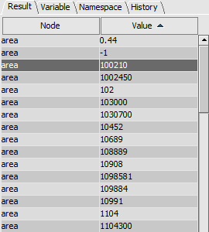

4.the official names of European countries (continent =Europe)

//country/infosContinent[continent='Europe']

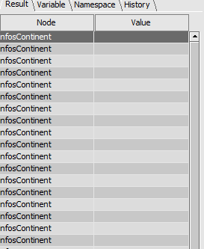

5.the common names of countries that do not haveany native name

//country/country_name/native_name[@lang=""]/common_name

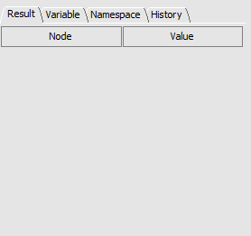 (no results)

6.the official names of the countries expressed in French, forthose who have such names

//country/country_name/native_name[@lang="fra"]/offic_name

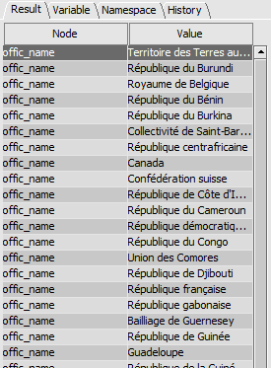

7.elements with at least one attribute

//*[@*]

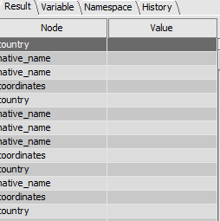

8. official names of the second native name of countries (for those who have)

//country/country_name/native_name[2]/offic_name/text()

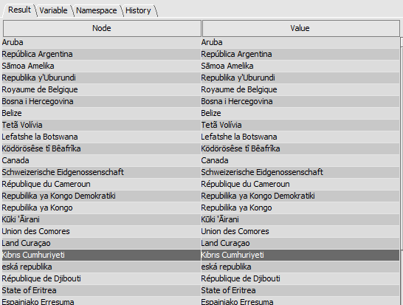

9.the sum of the surfaces (area) of the countries of Africa

sum(//country/infosContinent[continent="Africa"][/../@area](mailto:/../@area))

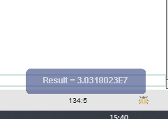

10.countries whose common name is not contained in theirofficial name

//country[country_name[not (contains(offic_name, common_name))]]

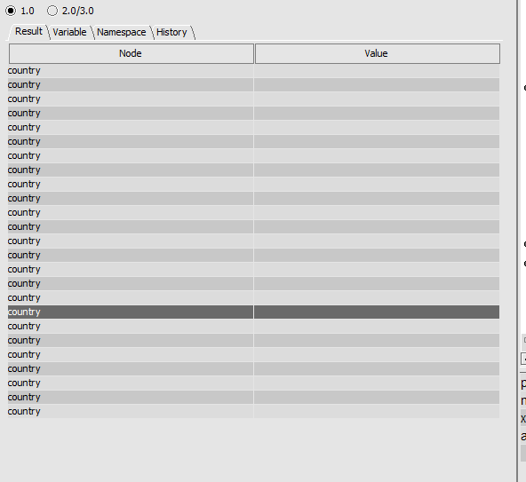

11.France's last neighbor

//country/country_name[common_name="France"]/../borders/neighbour[last()]

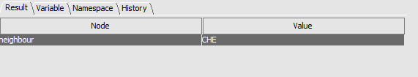

12.the position of France in the XML document

count(//country/country_name[common_name="France"]/../preceding-sibling::*)+1

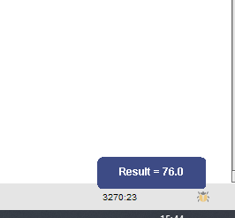

Step 2 :